**Introduction:**

It’s common to hear students complain about the dining hall food, often labeling it as “disgusting.” Personally, I’ve never found it to be that bad, but I became curious—do students truly dislike the campus food, or are they just exaggerating things? To answer this question, I decided to conduct a short survey to gauge students’ actual opinions about the food on our campus.

The survey consisted of two simple questions:

1. What is your student classification?
2. On a scale of 1 to 10, how would you rate the dining hall food at Western Illinois University?

After a few days of lobbying, I collected responses from 67 students, including individuals from my floor and various other circles I’m involved in. Below are the results of the survey and an analysis of the findings.

| Participant # | What is your student classification? | Rate the dinning hall food at WIU |
| --- | --- | --- |
| 1 | Sophomore | 8 |
| 2 | Sophomore | 7 |
| 3 | Sophomore | 4 |
| 4 | Freshman | 6 |
| 5 | Sophomore | 7 |
| 6 | Junior | 7 |
| 7 | Junior | 4 |
| 8 | Freshman | 7 |
| 9 | Junior | 4 |
| 10 | Freshman | 7 |
| 11 | Sophomore | 6 |
| 12 | Sophomore | 6 |
| 13 | Junior | 4 |
| 14 | Sophomore | 7 |
| 15 | Junior | 5 |
| 16 | Senior | 6 |
| 17 | Sophomore | 4 |
| 18 | Freshman | 6 |
| 19 | Junior | 7 |
| 20 | Senior | 3 |
| 21 | Sophomore | 7 |
| 22 | Junior | 8 |
| 23 | Freshman | 4 |
| 24 | Sophomore | 6 |
| 25 | Freshman | 8 |
| 26 | Sophomore | 5 |
| 27 | Sophomore | 6 |
| 28 | Junior | 6 |
| 29 | Junior | 6 |
| 30 | Sophomore | 6 |
| 31 | Sophomore | 4 |
| 32 | Freshman | 6 |
| 33 | Sophomore | 3 |
| 34 | Sophomore | 3 |
| 35 | Freshman | 6 |
| 36 | Freshman | 6 |
| 37 | Sophomore | 7 |
| 38 | Freshman | 4 |
| 39 | Sophomore | 3 |
| 40 | Sophomore | 4 |
| 41 | Sophomore | 7 |
| 42 | Junior | 7 |
| 43 | Sophomore | 7 |
| 44 | Freshman | 6 |
| 45 | Sophomore | 8 |
| 46 | Junior | 5 |
| 47 | Freshman | 7 |
| 48 | Sophomore | 8 |
| 49 | Sophomore | 8 |
| 50 | Freshman | 4 |
| 51 | Junior | 6 |
| 52 | Sophomore | 4 |
| 53 | Freshman | 6 |
| 54 | Sophomore | 4 |
| 55 | Freshman | 7 |
| 56 | Sophomore | 4 |
| 57 | Junior | 8 |
| 58 | Junior | 6 |
| 59 | Freshman | 7 |
| 60 | Senior | 5 |
| 61 | Freshman | 7 |
| 62 | Sophomore | 9 |
| 63 | Sophomore | 9 |
| 64 | Sophomore | 6 |
| 65 | Sophomore | 7 |
| 66 | Sophomore | 6 |
| 67 | Junior | 6 |

**Survey Composition:**

The survey collected input from a diverse group of students, including 17 freshmen (25%), 32 sophomores (48%), 15 juniors (22%), and 3 seniors (4%). This distribution ensures that the results are fairly representative of the student body, with the largest proportion of respondents being sophomores.

| **Grade Level** | **Count of Grade Level(Q1)** | Cum% |
| --- | --- | --- |
| Freshman | 17 | 25% |
| Sophomore | 32 | 48% |
| Junior | 15 | 22% |
| Senior | 3 | 4% |
| **Grand Total** | **67** | 100% |

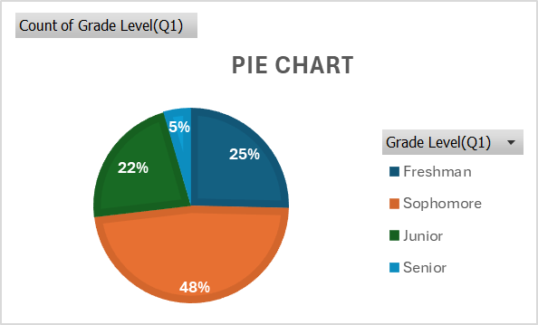

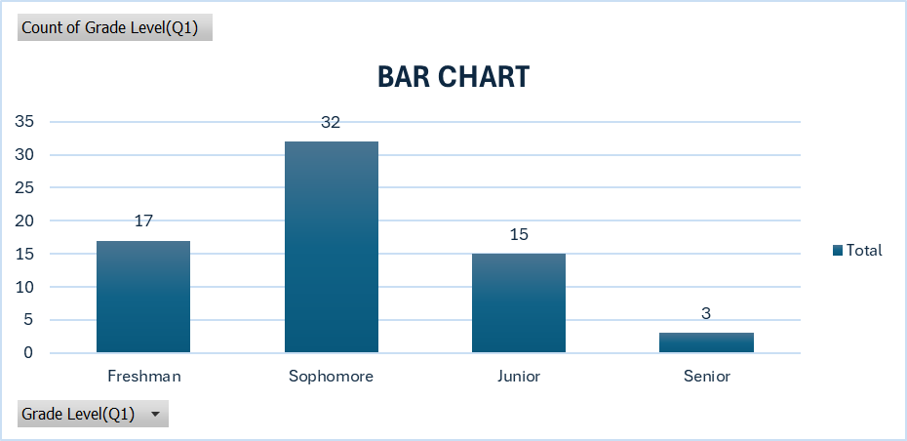

**Qualitative Data:**

The ratings for the dining hall food ranged from a minimum of 3 to a maximum of 9, with the mean score being 5.93. This suggests that students’ opinions about the food are pretty neutral, not great, but a far cry from the opinions I hear floating around. These results indicate that while some students have strong negative feelings about the dining hall food, others are relatively satisfied, with most ratings clustering around 6. Below are the key metrics for a more comprehensive breakdown:

| **Mean** | 5.925373 |
| --- | --- |
| **Standard Error** | 0.186996 |
| **Median** | 6 |
| **Mode** | 6 |
| **Standard Deviation** | 1.530631 |
| **Sample Variance** | 2.342831 |
| **Range** | 6 |
| **Minimum** | 3 |
| **Maximum** | 9 |
| **Count** | 67 |

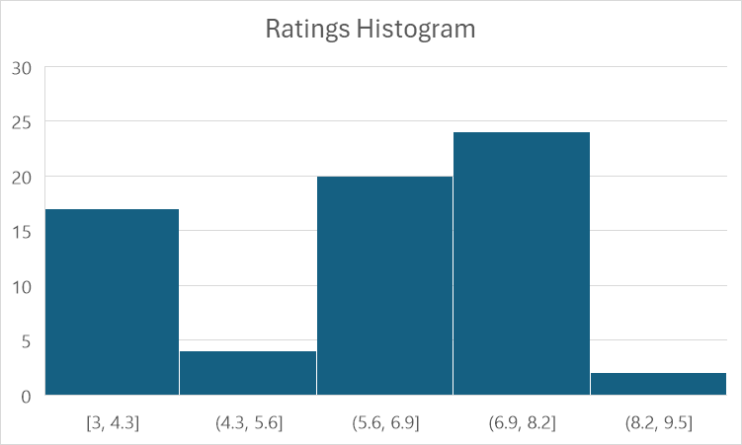

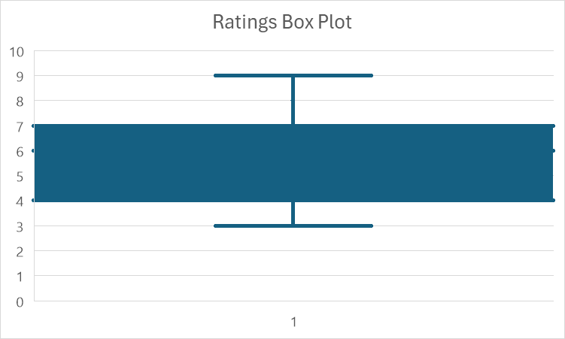

**Conclusion:**

Wrapping things up, the results of this survey provide a very comprehensive insight into the student body's perceptions of the dining hall food at Western Illinois University. While some students genuinely do not like the food, the overall opinion leans towards neutrality, with a mean rating of 5.93. This suggests that many students find the food to be adequate, though not outstanding. A far cry from the incredibly negative reviews I’ve heard in casual conversation.

The survey's diverse participant pool, comprising 25% freshmen, 48% sophomores, 22% juniors, and 4% seniors, ensures a fairly representative sample of the student body. Additionally, the distribution of ratings, with a median and mode of 6, shows that most students have a centered opinion of the food.

In conclusion, the general perception of dining hall food at WIU is not as overwhelmingly negative as many students describe. Instead, it reflects a mixed bag of opinions, with room for improvement to better meet the diverse tastes and expectations of the student body. Hopefully, the university can work towards enhancing the overall dining experience for all students.